AWS VPN Setup

Prerequisites

Install the client downloaded from the AWS Client VPN download link. AWS Client VPN link to download: AWS Client VPN Download Windows and MAC

Download the Client VPN profile. Client VPN profile to download: VPN Profile Download

Windows and Mac Setup (Both Setups do the same process)

- Open the AWS VPN Client App.

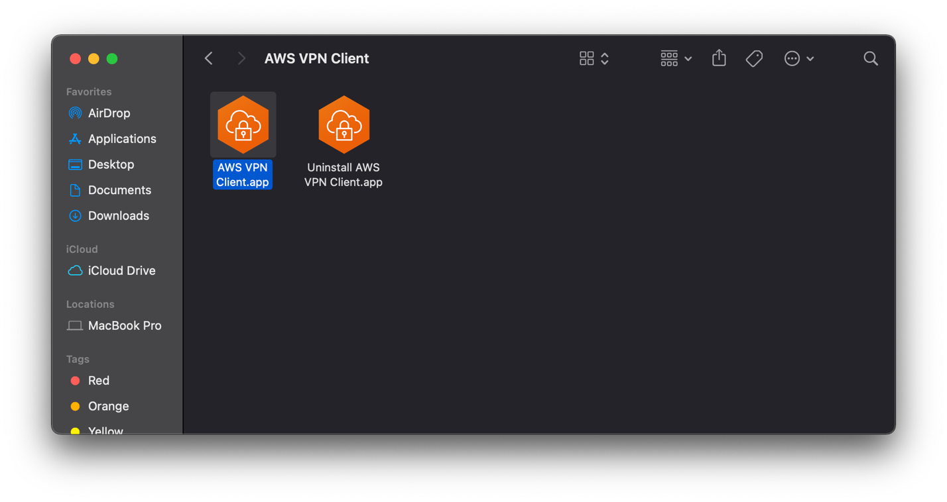

- Go to File > Manage profiles. Click Add Profile, and enter PMG VPN in the Display Name, browse to the VPN Profile download in the prerequisites, and click Add Profile.

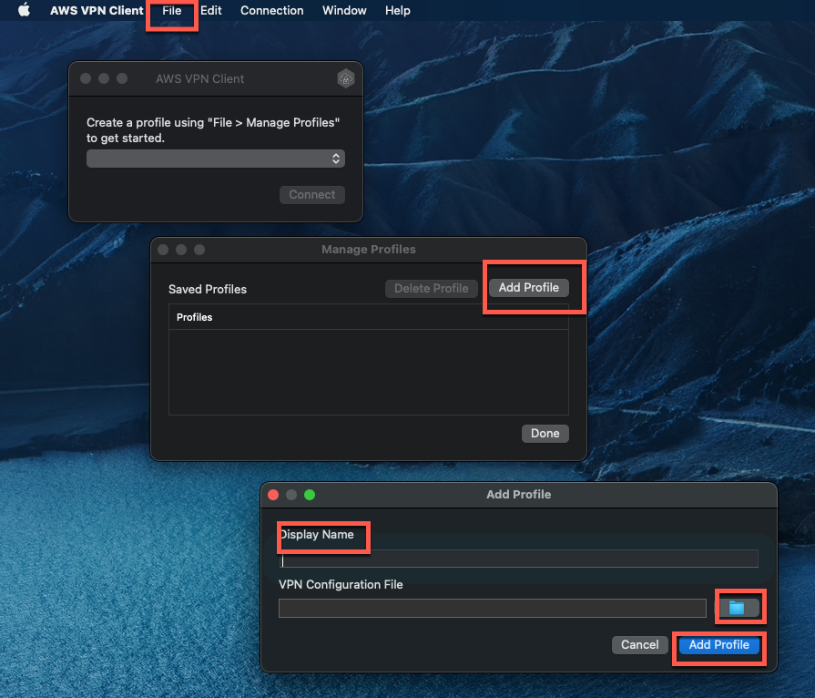

- Click connect.

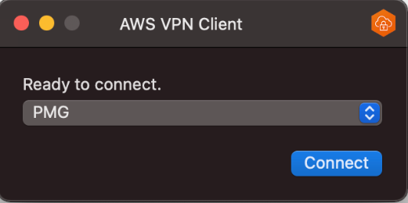

- You will be prompted to log on to Google using your PMG credentials.

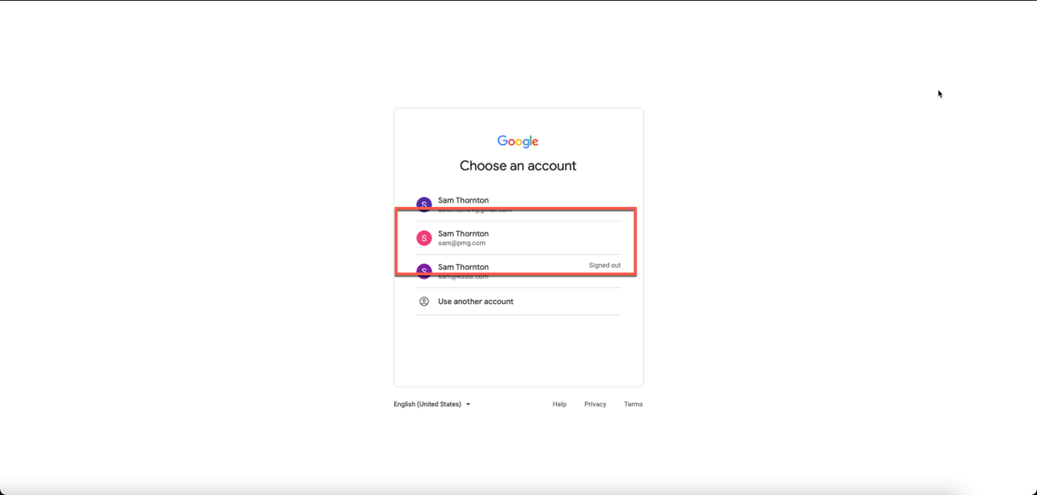

- You can confirm your connection on the client app.

